Milestone Two

Model Applicability & Value

Michael Surdek
Southern New Hampshire University
DAT 650: Advanced Data Analytics
Professor Letia Sheldon
July 3, 2022
The data set that GE has compiled from their monthly reporting system is well suited for the purposes of building an analytical model to predict customers who are likely to churn. With that said, there is still work to be done to properly select and prepare the data before the modeling phase of the CRISP-DM process. For example, CHURNDEP, the target variable, contains NAs for customers who should be excluded from training the model so that they can be utilized to validate its results afterwards. Additionally, there are certain attributes in the source file that need not be included, such as CUSTOMER, a unique identifier which will serve no predictive purpose, and CHURN, which is the same as CHURNDEP without the missing values and would therefore predict CHURNDEP with 100% accuracy. With just a few lines of code in R, these preliminary steps can be accomplished and the rest of the data can be explored further.
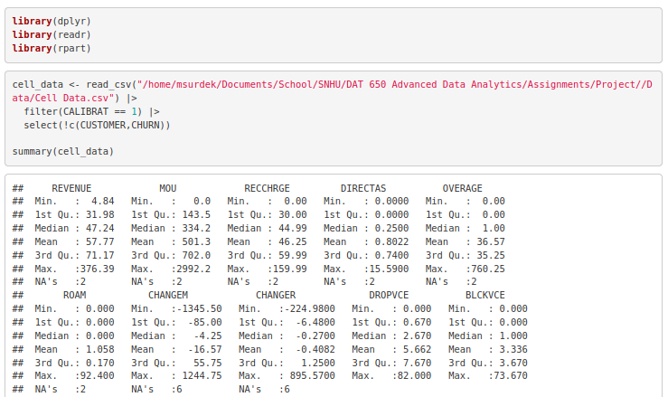
There are approximately 30 fields that pertain to cellular coverage, equipment, and average usage patterns. The remaining fields include information on each individual such as family makeup, credit rating, occupation, and customer service history. Only 3 fields include categorical values, and the others are numeric, although some of these represent categories and are stored as binary numbers 1 and 0. In fact, 2 of the 3 categorical fields are labels for those binary variables just mentioned. Trial and error in the modeling phase can determine whether it is better to use the labels or the dichotomized values. This data can now be fed into a basic test model to gauge the feasibility of the design and reveal any hidden details that should be addressed when we return to the data understanding and preparation phases.
The family of algorithms that can accomplish this predictive task is known as classification techniques. "Classification algorithms are supervised methods that look for and discover the hidden associations between the target class and the independent variables. Supervised learning algorithms allow tags to be assigned to the observations, so that unobserved data can be categorized based on the training data." (Dogan, 2012) There are many classification techniques including logisitic regression, naive bayes, support vector machines, or tree based methods such as CART, random forest, and gradient boosting machines. Tree based methods have been shown to be excellent predictors of binary target outcomes, especially when applied through ensemble learning and/or boosting methods. Random forest is an ensemble of simple decision trees that makes a final prediction based on the majority of predictions from all of the separate trees. A random forest should be a good fit for predicting customer churn based on the available data, but to test the design and validity of the strategy we can develop a basic decision tree using the rpart package in R.
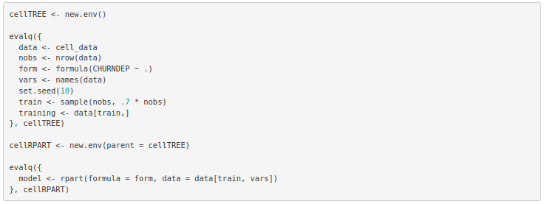

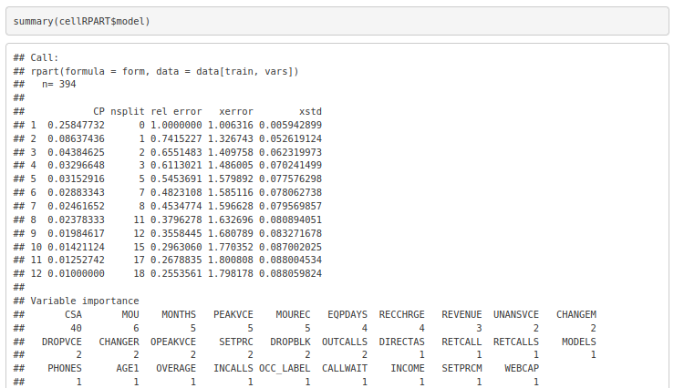
The summary of this basic decision tree shows how the error decreases as it becomes deeper with more splits. This makes sense for the error on the training data, but it will be important to evaluate the optimal depth of the tree as it relates to performance on unseen data. The summary also shows which variables have the largest impact on the prediction of whether or not a customer will churn. CSA, the most important variable, is the third and final categorical field and includes the communications service area for each customer. With this information, it appears that geographical location plays a big role in customer churn, and that might have to do with the cell service in each area. The next most important variable is the mean monthly minutes of use for each customer. This also makes sense because those who use fewer minutes likely have less need for the service and are more likely to cancel. Finally, some other variables that seem to be important from this test model are months in service, number of calls during peak times, and mean received calls.
Based on the results of this initial decision tree, it is clear that a predictive model can identify attributes that make a customer more likely to cancel their subscription. Further, to directly add value to the business, a predictive model can quantify the likelihood of any customer cancelling their subscription. If the model were scored for each subscriber on a regular basis, those most likely to churn could be approached with alternative offers or potential resolutions to their concerns. This would ideally allow GE to prioritize their outreach and ultimately lead to fewer cancellations.
GE is committed to understanding and improving the problems that are causing customers to churn, and through the CRISP-DM process, they can uncover insights that will not only provide business value, but also inspire further projects and analysis to solve more complex and beneficial problems. “Lessons learned during the data mining process and from the deployed solution can trigger new, often more focused business questions.” (Shearer, 2000) Accorinding to the important attributes identified from the test model, a focused business question that comes to mind is which communication service areas actually have poor cell service and are causing customer churn? The answer to this question could help GE avoid areas that are known to have poor service and to target prospects in areas where they are more certain that the service will not cause issues.
References:

Dogan, Neslihan et al. A comparative analysis of classification algorithms in data mining for accuracy, speed and robustness. 2012. Springer Science+Business Media, LLC. Retrieved from https://www.proquest.com/docview/1365805269/fulltextPDF/DC122D39D5694F19PQ/1? Accountid=3783

Shearer, Colin. (2000). The CRISP-DM Model: The New Blueprint for Data Mining. The Journal of Data Warehousing. Retrieved from https://mineracaodedados.files.wordpress.com/2012/04/the- crisp-dm-model-the-new-blueprint-for-data-mining-shearer-colin.pdf

